

**UNIVERSITY INSTITUTE OF ENGINEERING**

**Department of Computer Science & Engineering**

|  |  |
| --- | --- |
| **Submitted By:                                                                          Submitted To:**  Rahul Kumar (20BCS7081) Er. Nitsha (E13137) | |
| **Subject Name** | Data Mining |
| **Subject Code** | 20CSP_376 |
| **Branch** | CSE |
| **Semester** | 6th |

**Experiment 1.3**

**Student Name: Rahul Kumar UID: 20BCS7081**

**Branch: BE-CSE Section/Group:20BCS_DM-716 B**

**Semester: 6 Date of Performance: 28 Feb 2023**

**Subject Name: DM LAB Subject Code: 20CSP_376**

**AIM :-**

Demonstration of association rule mining using Apriory algorithm on supermarket data.

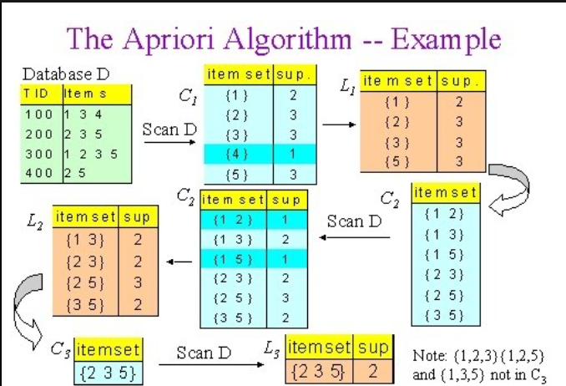

**Code And Output :-**





